Q1

import java.util.Scanner;  
class box{  
 int width,height;  
 // Parameterised constructor  
 public box(int w,int h){  
 this.width = w;  
 this.height = h;  
 }  
 public String print(){  
 return "HEIGHT IS "+height+"Width is "+width;  
 }  
}  
public class Main {  
 public static void main(String[] args) {  
 System.*out*.println("Hello world!");  
 Scanner get = new Scanner(System.*in*);  
 int heigh,width;  
 System.*out*.println("Enter height and width \nBox 1");  
 heigh = get.nextInt();  
 width = get.nextInt();  
 if (width>0 && heigh>0){  
 box b1 = new box(heigh,width);  
 System.*out*.println(b1.print());  
 }  
 System.*out*.println("Box 2");  
 box b2 = new box(get.nextInt(), 5);  
 System.*out*.println("Box 3");  
 box b3 = new box(get.nextInt(),get.nextInt());  
 System.*out*.println(b2.print());  
 System.*out*.println(b3.print());  
 }  
}

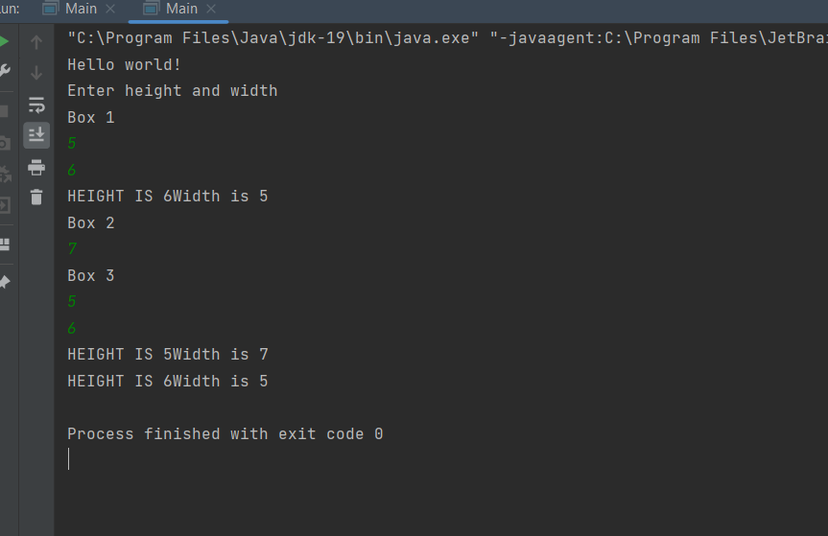

Q2class pk{  
 public String Language;  
 public pk(){  
 Language="JAVA";  
 }  
 public pk(String set){  
 this.Language = set;  
 }  
 public String display(){  
 return "Lamguage is "+Language;  
 }  
}  
public class Main {  
 public static void main(String[] args) {  
 pk a1 = new pk();  
 pk a2 = new pk("C");  
 System.*out*.println(a1.display());  
 System.*out*.println(a2.display());  
 }  
}

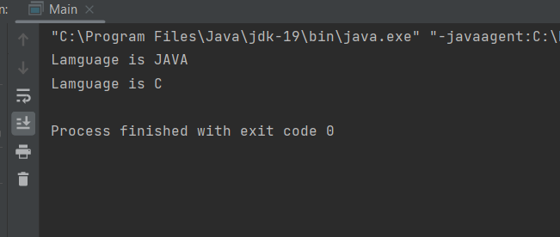

Q3

class Holiday{  
 public String name;  
 public int day;  
 public String month;  
 public Holiday(String name,int day,String month){  
 this.day = day;  
 this.month = month;  
 this.name = name;  
 }  
 public boolean isSameMonth(Holiday obj){  
 return this.month.equals(obj.month);  
 }  
 public String Display(){  
 return "Name is "+name+"\nDay is "+day+"\nMonth is "+month;  
 }  
}  
public class Main {  
 public static void main(String[] args) {  
 System.*out*.println("Hello world!");  
 Holiday obj = new Holiday("Independence day",14,"August");  
 Holiday obj2 = obj;  
 System.*out*.println(obj2.Display());  
 }  
}

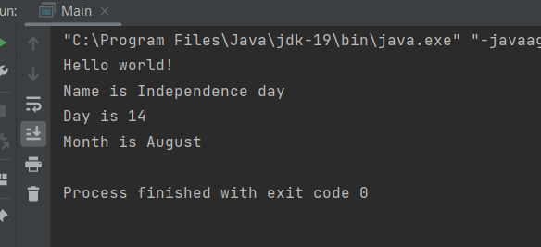

Q4

class tank{  
 boolean full = false;  
 void empty(){  
 full=false;  
 }  
 void fill(){  
 full=true;  
 }  
 protected void finalize(){  
 if(full){  
 System.*out*.println("Terminated");  
 }  
 }  
}  
public class Main {  
 public static void main(String[] args) {  
 System.*out*.println("Welcome to java");  
 tank t1 = new tank();  
 t1.fill();  
 tank t2 = t1;  
 t1.finalize();  
  
 }  
}

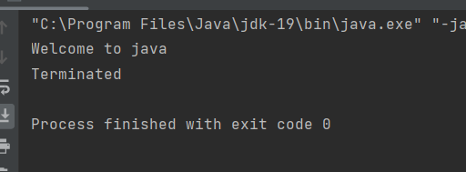

Q5

class garbadge{  
 int rollNo;  
 public garbadge(){  
 System.*out*.println("Object created");  
 }  
 protected void finalize(){  
 System.*out*.println("Object Deleted");  
 }  
}  
public class Main {  
 public static void main(String[] args) {  
 System.*out*.println("Welcome to java");  
 garbadge G1 = new garbadge();  
 G1 = null;  
 System.*gc*();  
 G1.finalize();  
 }  
}

